# EssEv installation guide

## Installation device

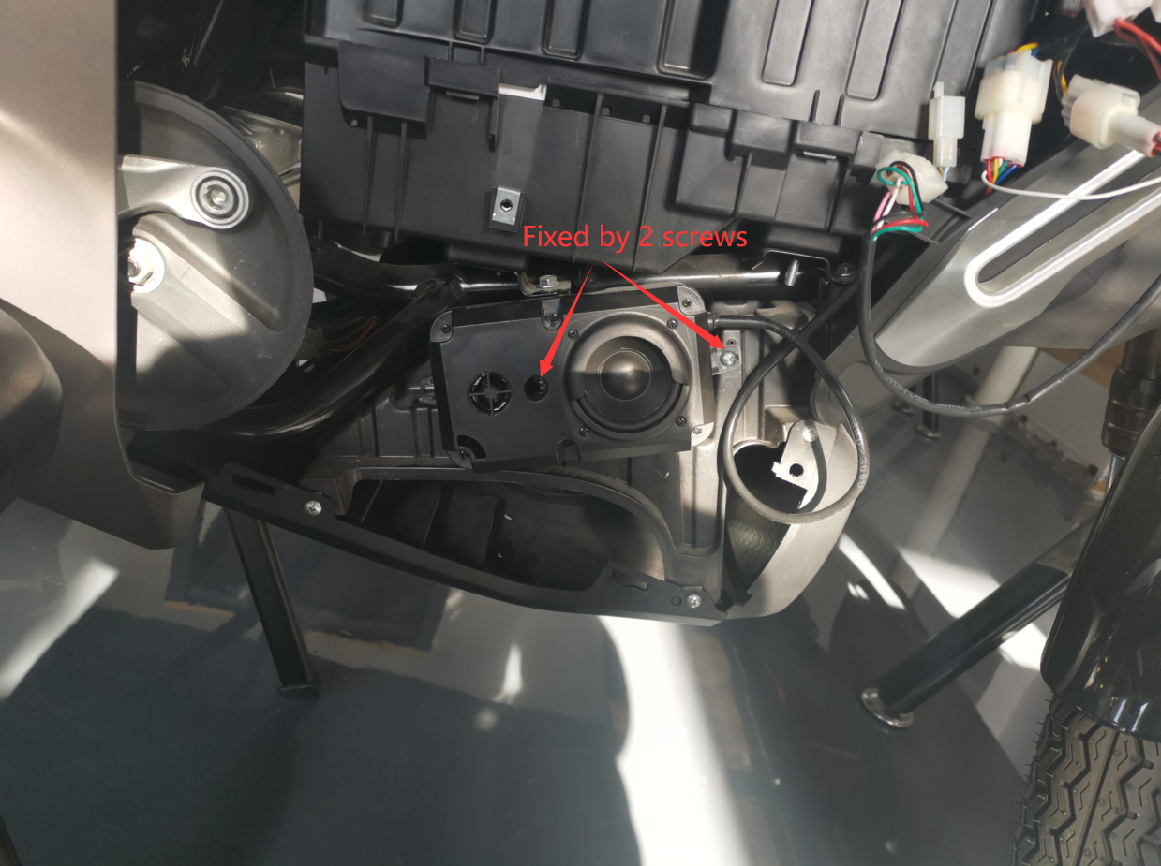

1. Mount the EssEv in this position.
2. Fixed the device by 2 screws as in the pictures.

## Connect EssEv to adapter cable

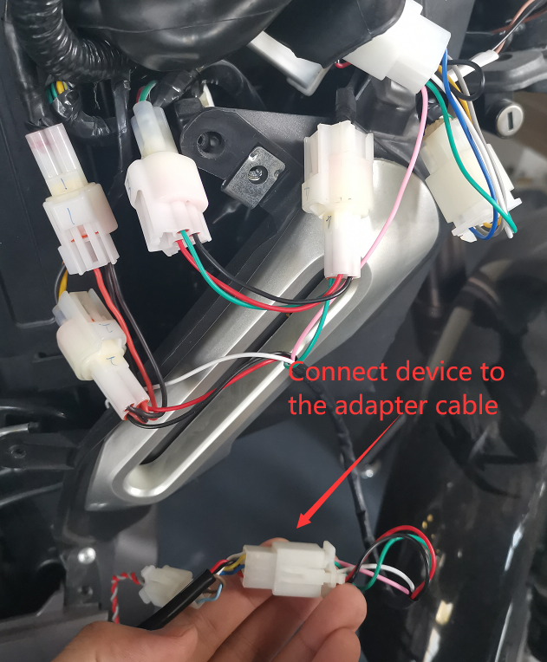

## Connect the adapter cable to the motor wire

### Power connector

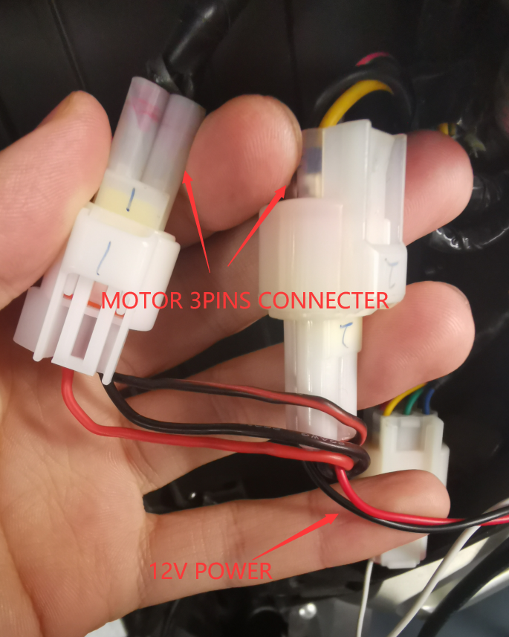

1. Disconnect the 3pins connector on the motor. The color of 3 wires are black, red/black and yellow.
2. Connect the 3pins power connector between the connector in last step.

### Throttle connector

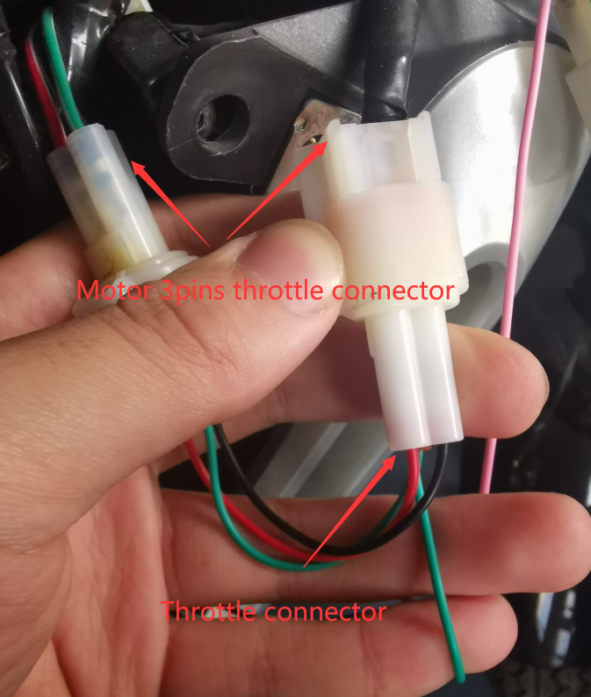

1. Disconnect the 3pins connector on the motor. The color of 3 wires are black/white, red/white and green/white.
2. Connect the 3pins throttle connector between the connector in last step.

### HALL connector

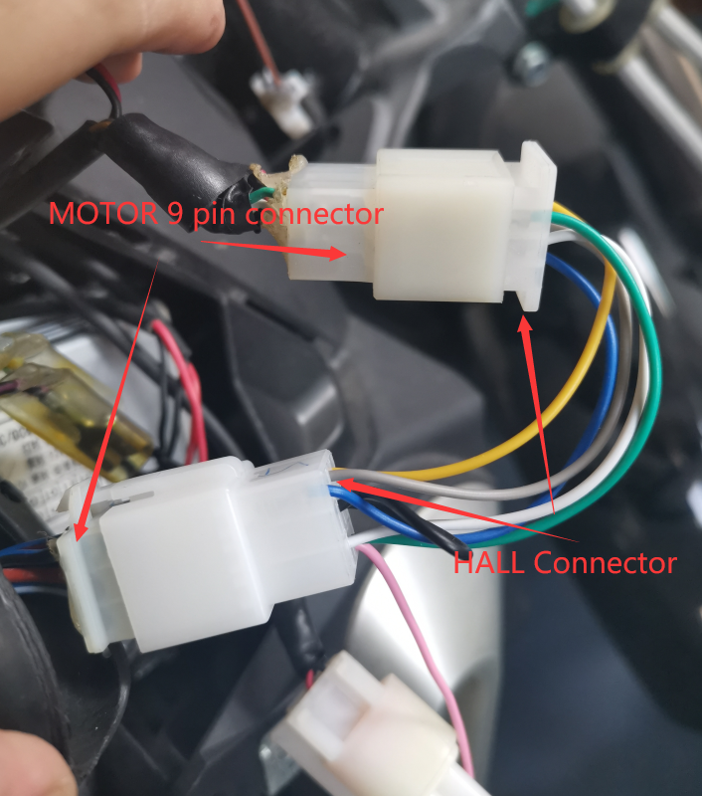

1. Disconnect the 9pins connector on the motor which has total 7 wires. The color of 7 wires are white/blue, brown, black/blue, blue/purple, black, black/purple, blue/green.
2. Connect the 9pins HALL connector between the connector in last step.

### Mode connector

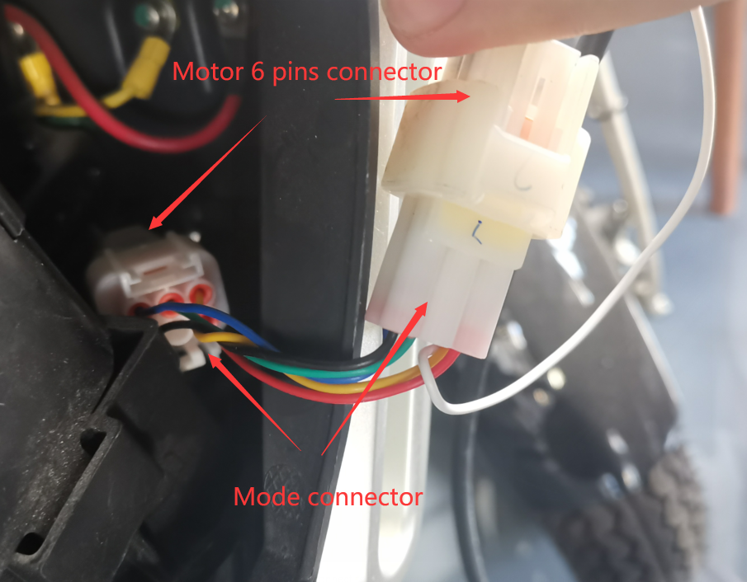

1. Disconnect the 6pins connector on the motor which has total 5 wires. The color of 5 wires are red, black, green, blue and yellow.
2. Connect the 6pins Mode connector between the connector in last step.